|  |  |
| --- | --- |
| **NAME** | **YOGESWARI M** |
| **PROJECT NAME** | **BUILD AND EMAIL CAMPAIGN : CREATE A BRAND LAUNCH -USING MAILCHIMP** |
| **DEPARTMENT** | **COMPUTER SCIENCE AND ENGINEERING** |
| **COURSE DETAILS** | **DIGITAL MARKETING** |
| **COLLEGE** | **DHANALAKSHMI SRINIVASAN INSTITUTE OF TECHNOLOGY** |
| **TEAM ID** | **NM2023TMID03430** |
| **NM ID** | **F62E82281221FD6A60247B9C3D0BF00A** |
| **ZONE** | **12** |

**ABSTRACT :**

**Page Crafters is a web design and development tool that empowers user to create visually appealing and function web page. With user – friendly interface and variety of customizable templates , Page Crafters enables user to design , edit and publish web pages without the need for extensive coding or technical expertise. This platform is an invaluable resource for individuals and business seeking to establish an online presence snd engage with their target audience effectively**

**LOG INTO MAILCHIMP**

**STEP 1**

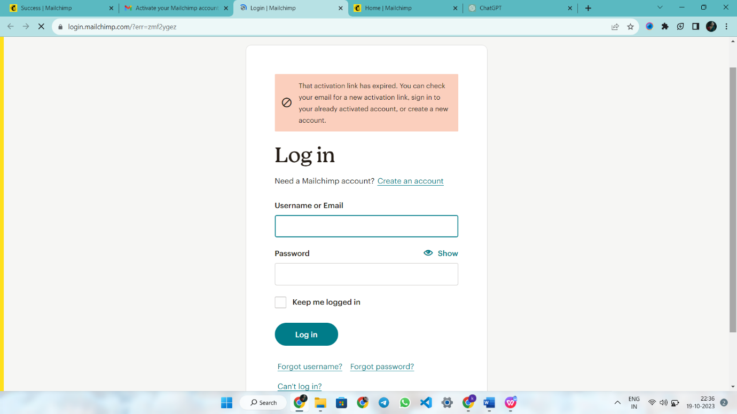

**STEP 2**

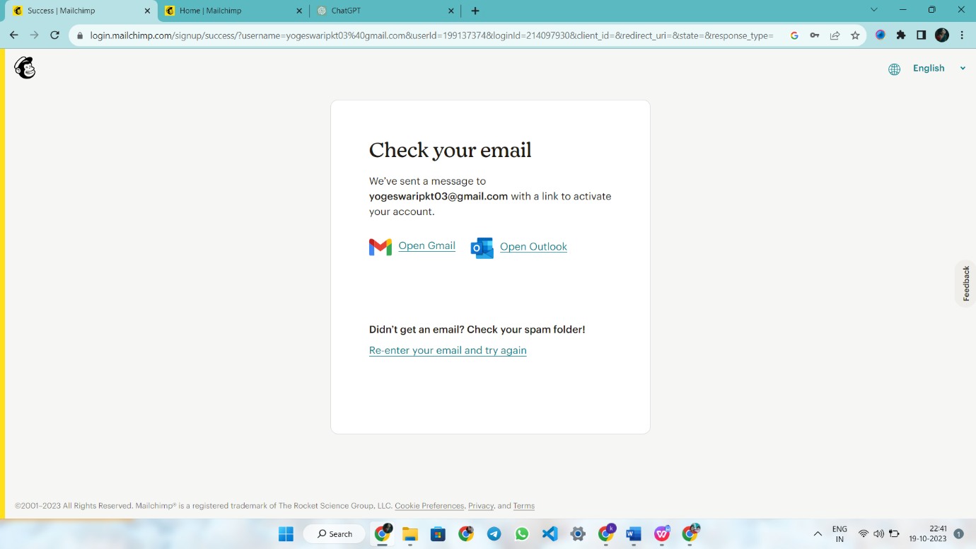

**STEP 3**

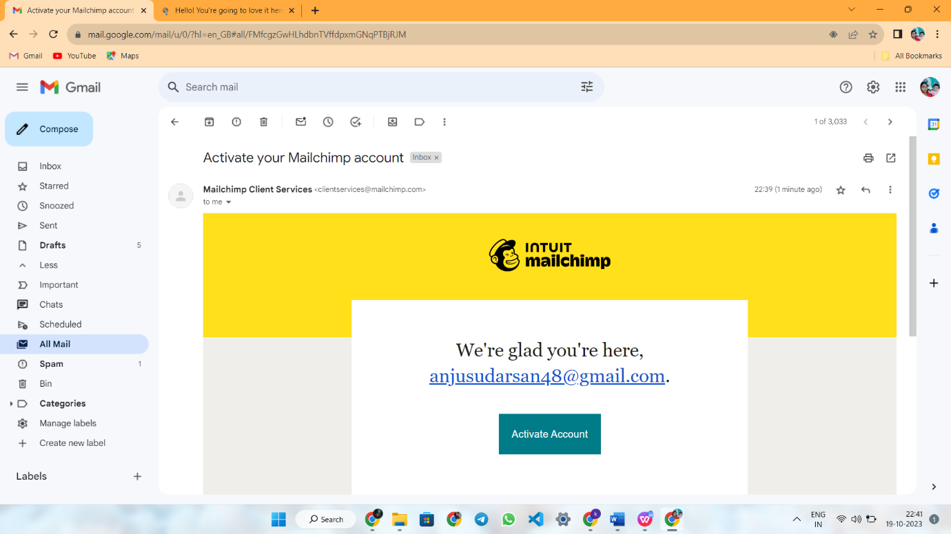

**STEP 4**

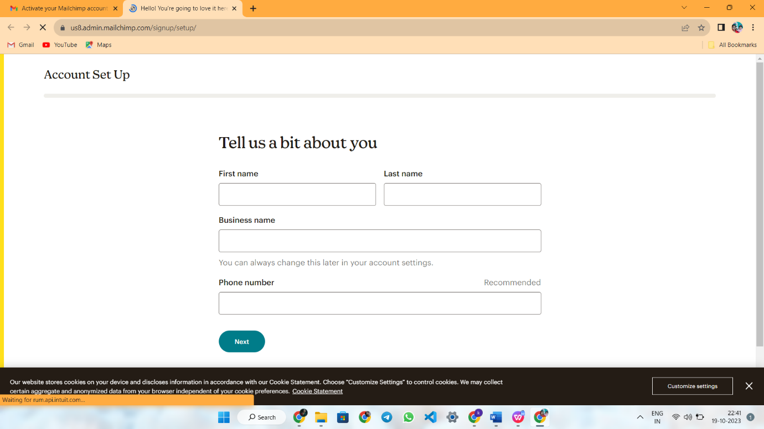

**STEP 5**

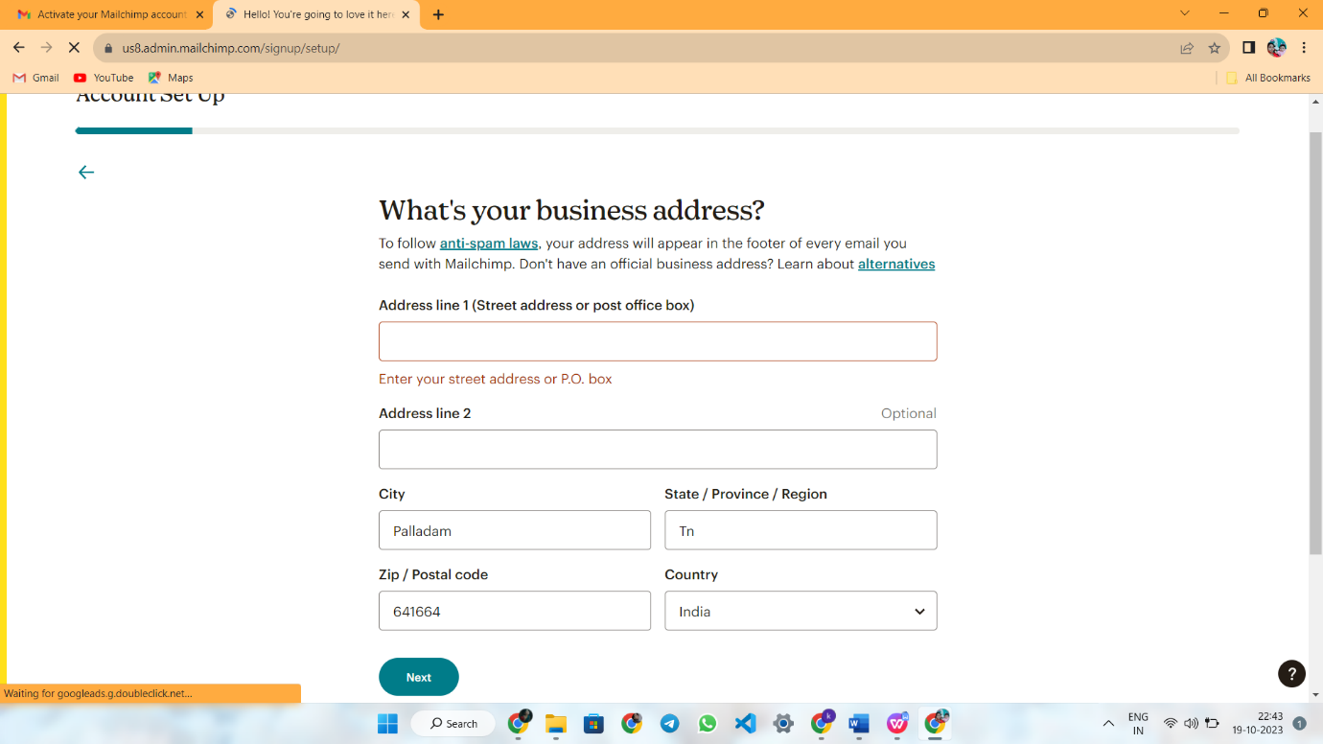

**STEP 6**

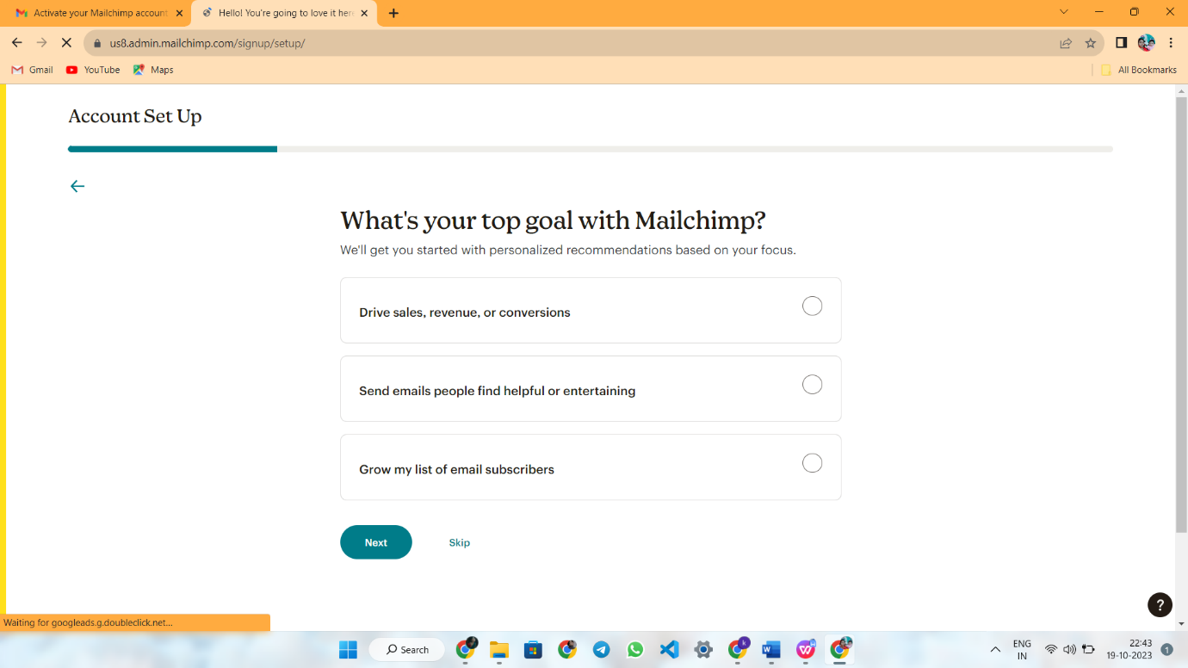

**STEP 7**

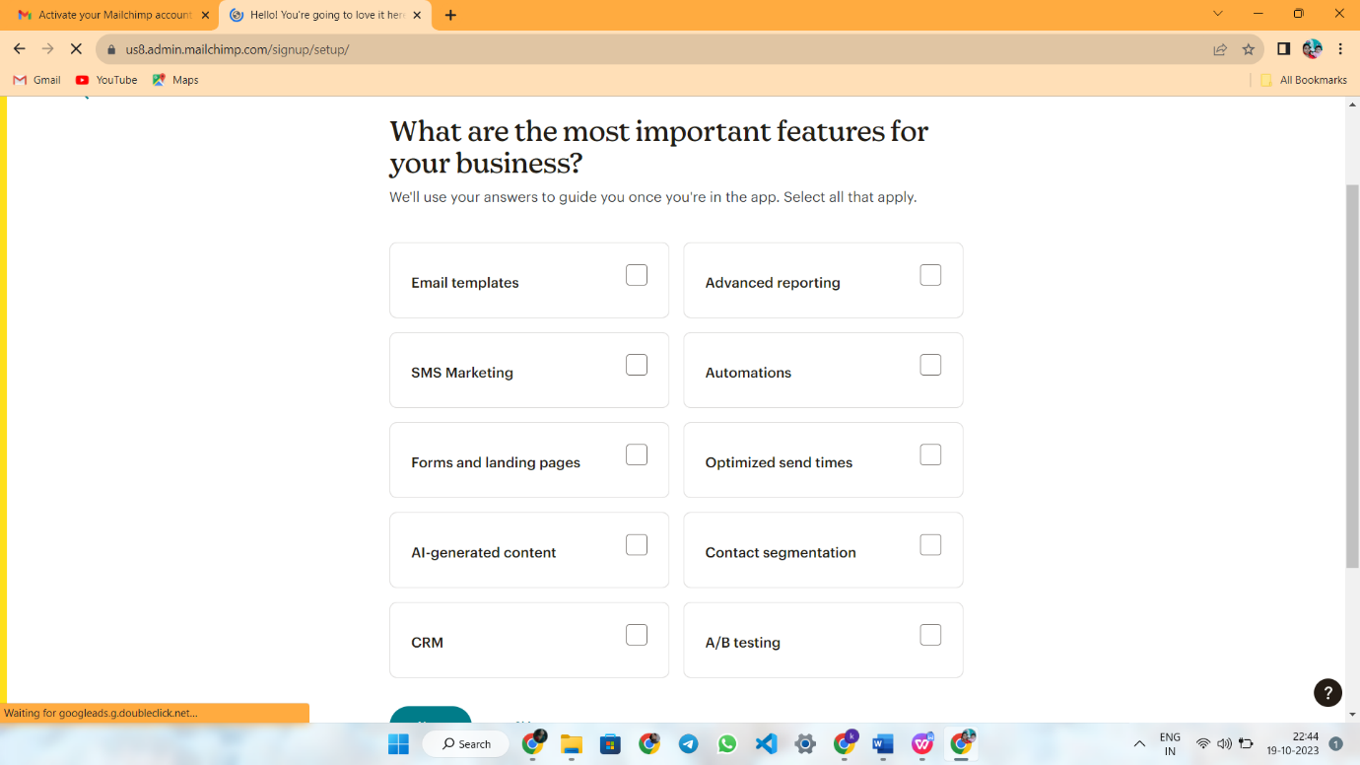

**STEP 8**

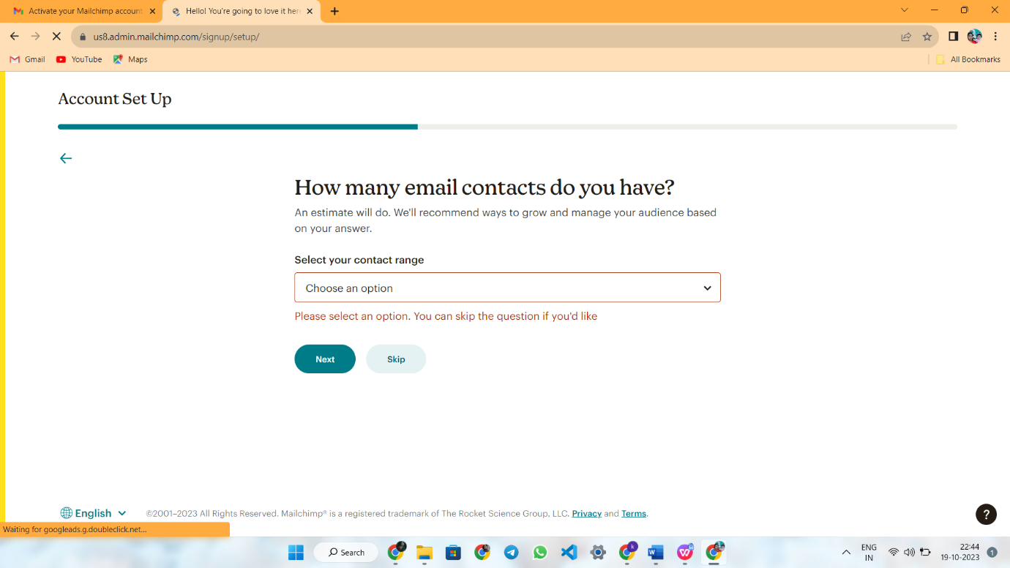

**STEP 9**

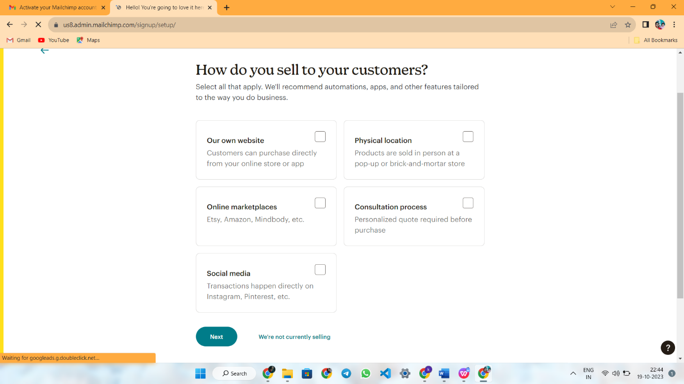

**STEP 10**

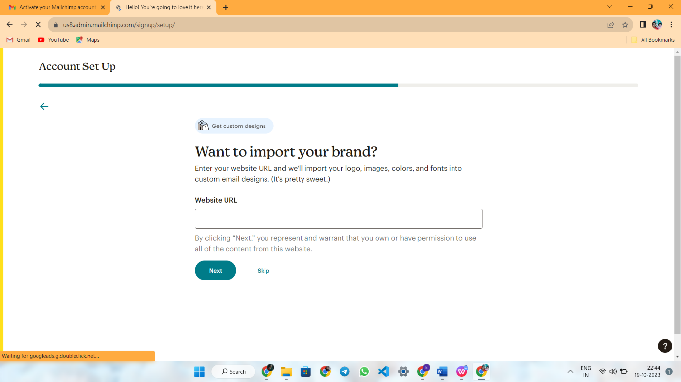

**STEP 11**

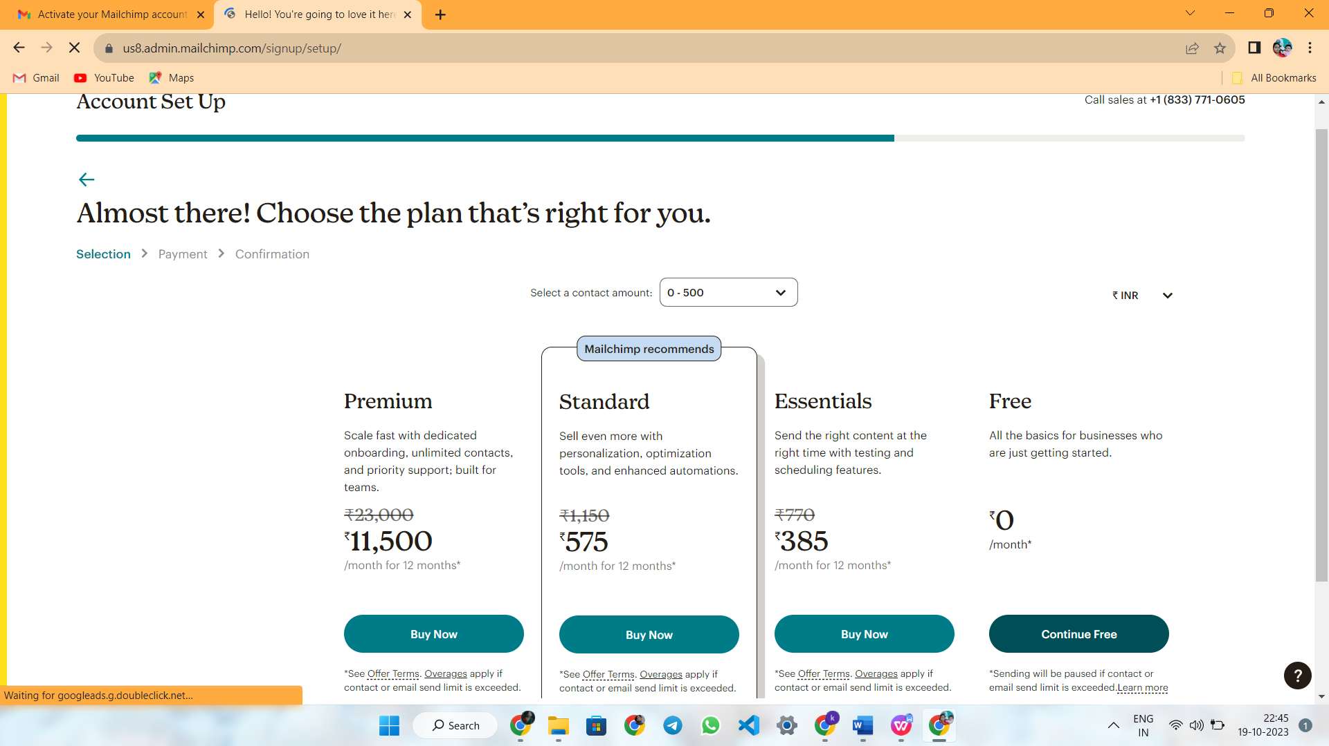



**CREATE NEW CAMPAIGN**

**STEP 1**



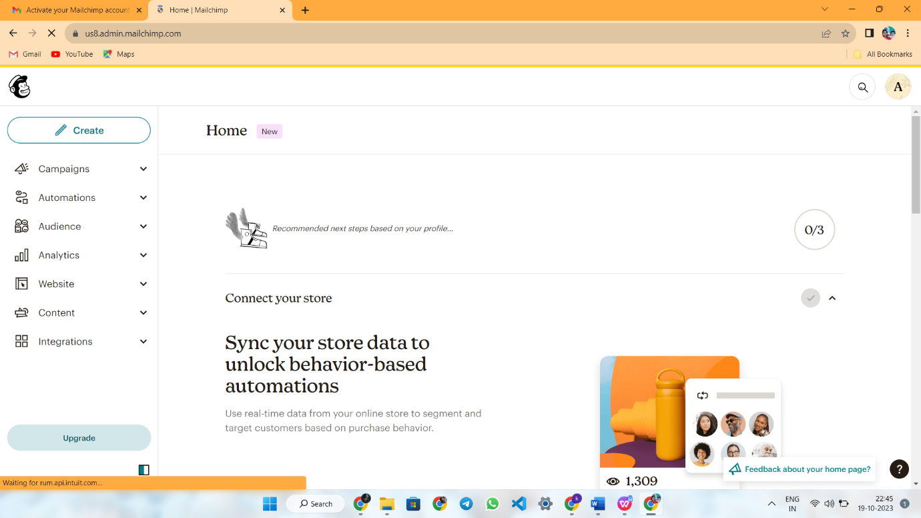

**STEP 2**

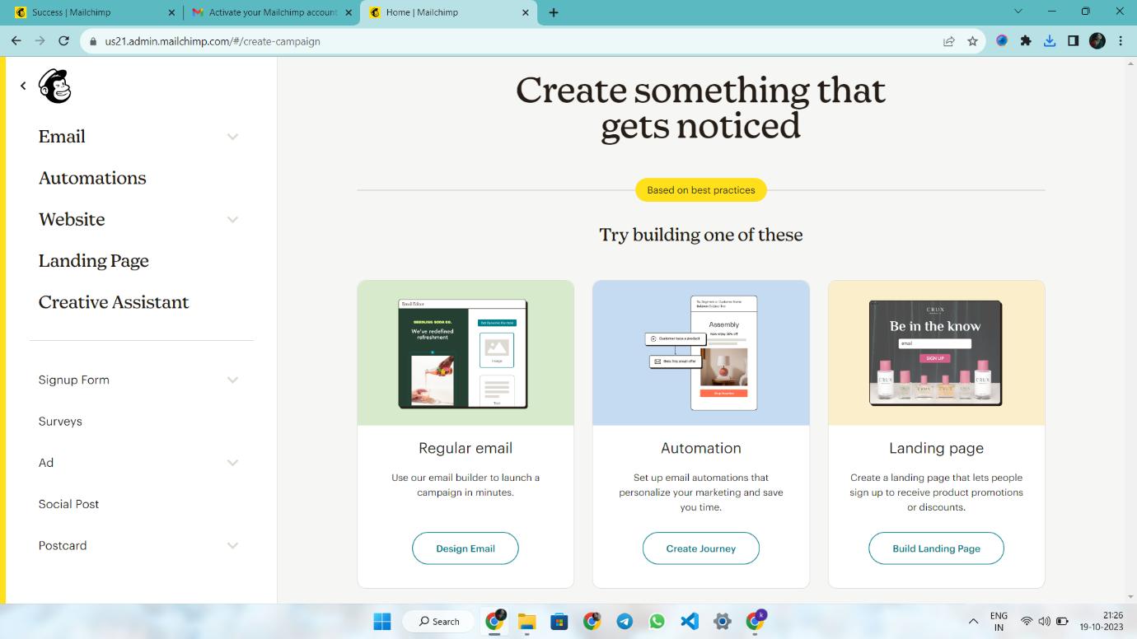



**STEP 3**

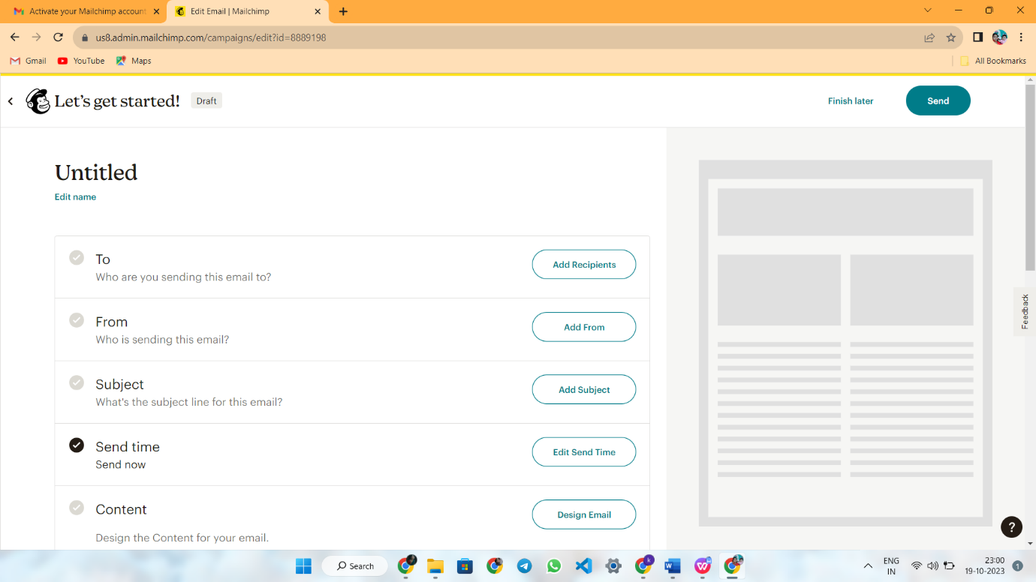

**STEP 4**

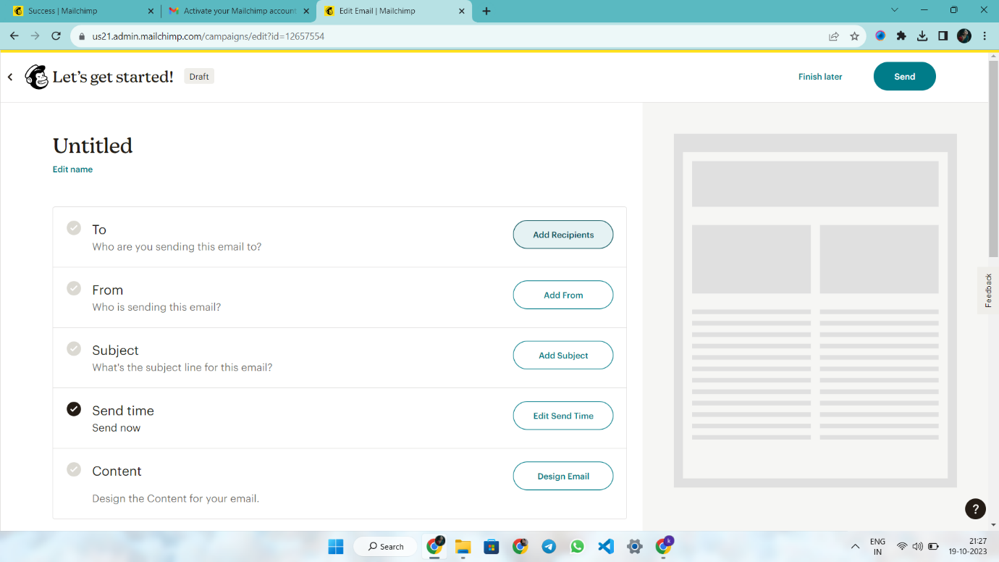

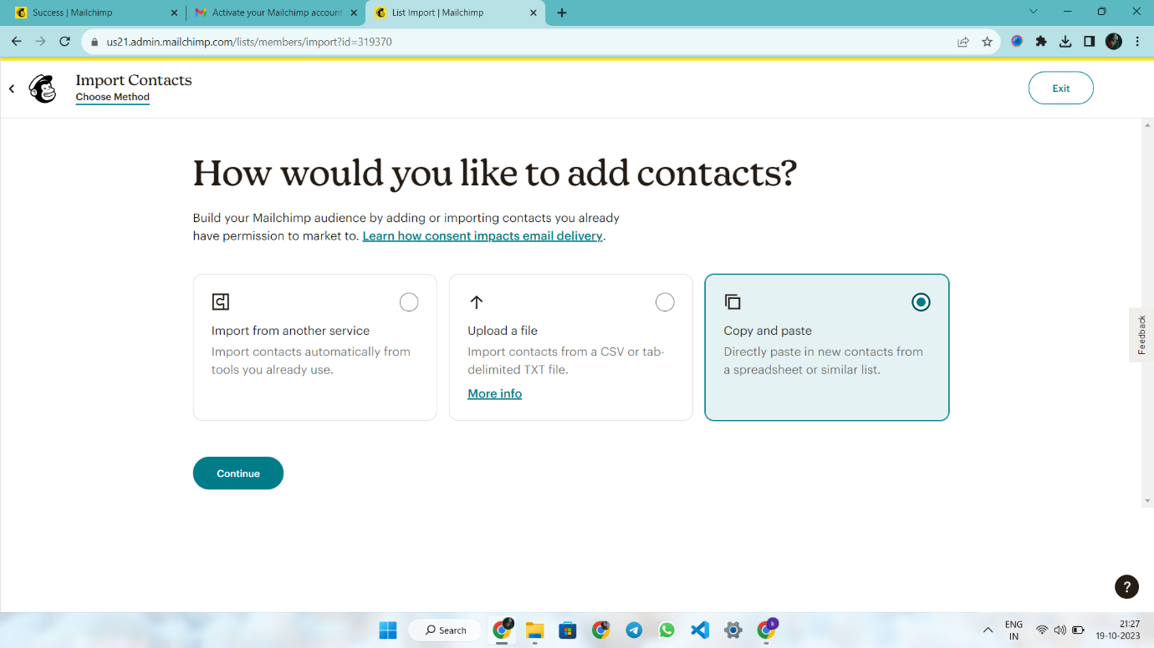

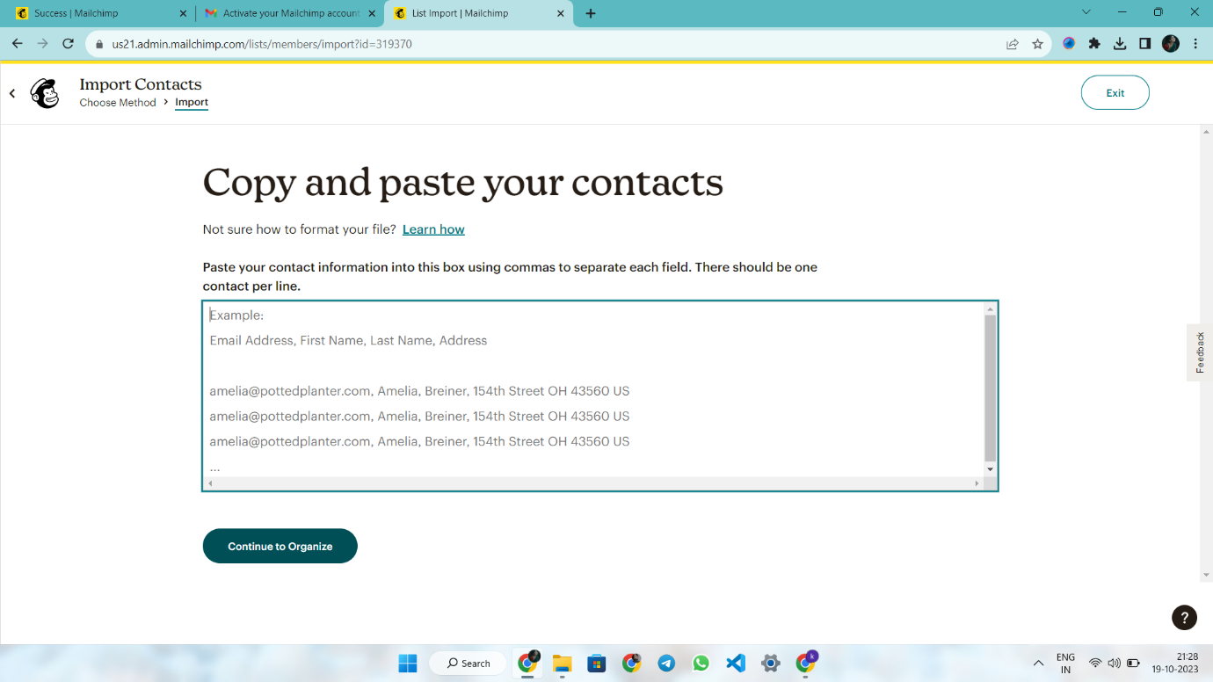

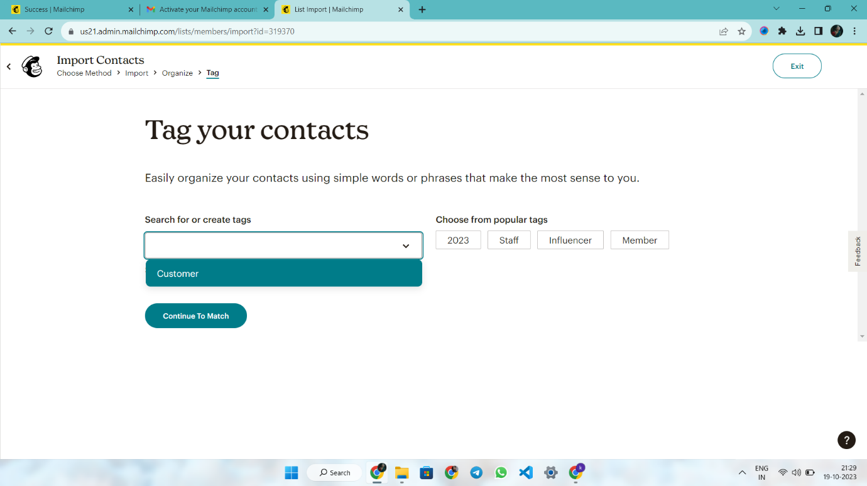

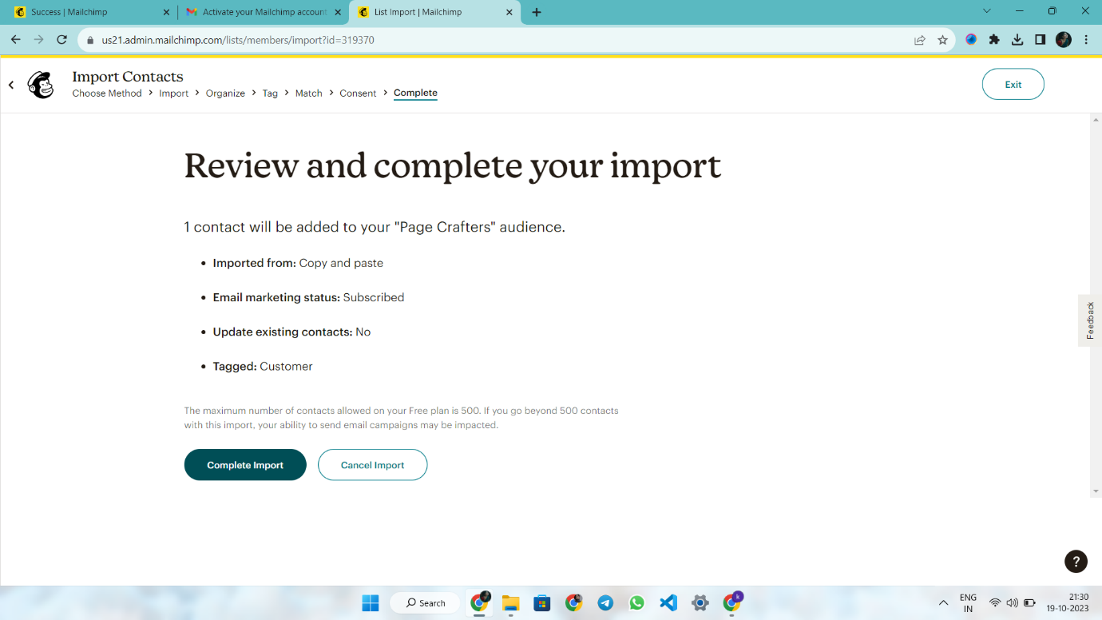

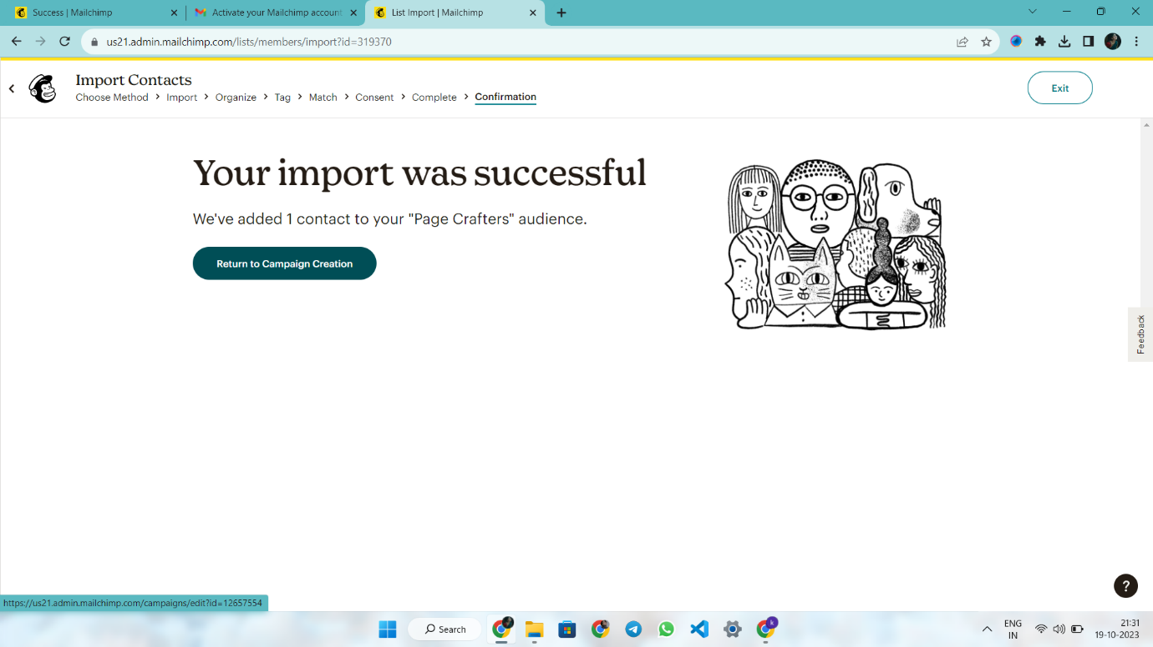

**STEP 5**

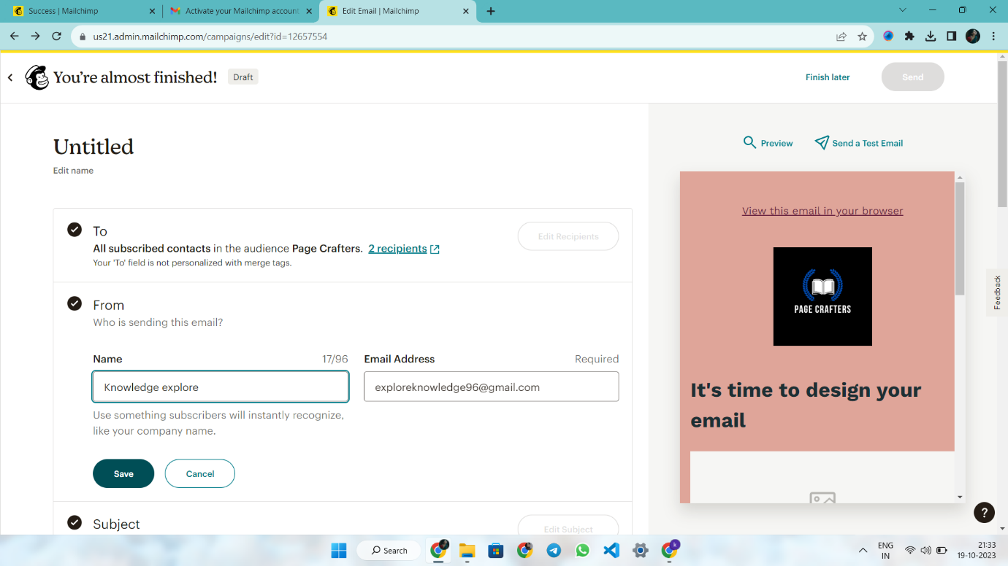

**STEP 6**

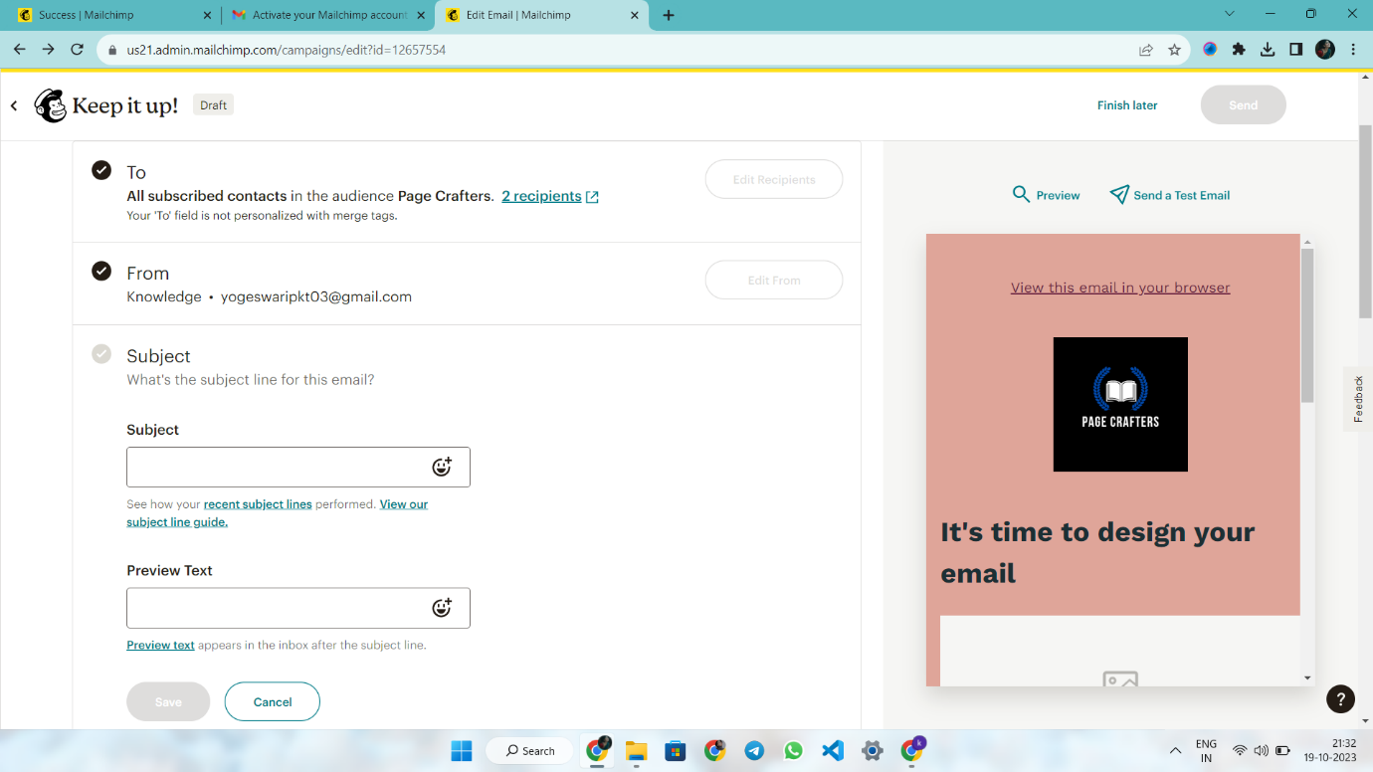

**DESIGN A CAMPAIGN**

**STEP 1**

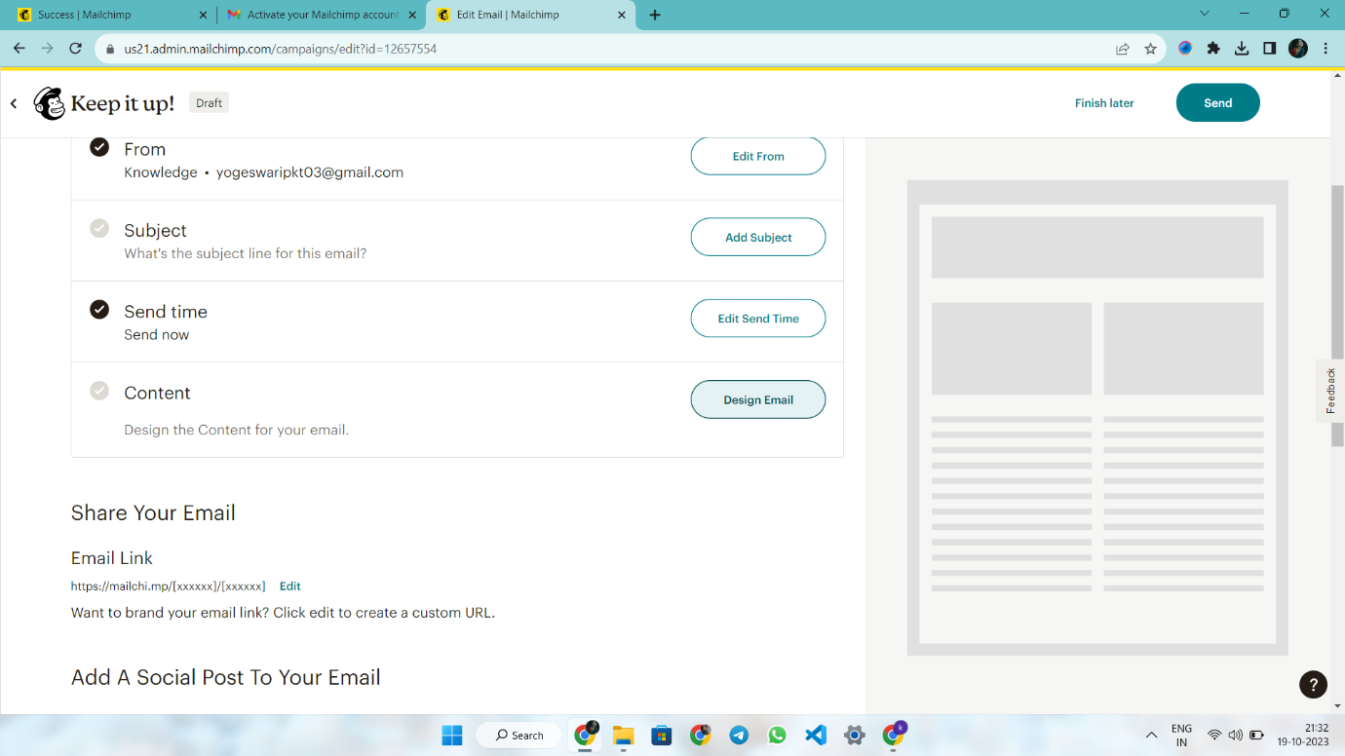

**STEP 2**





**STEP 3**



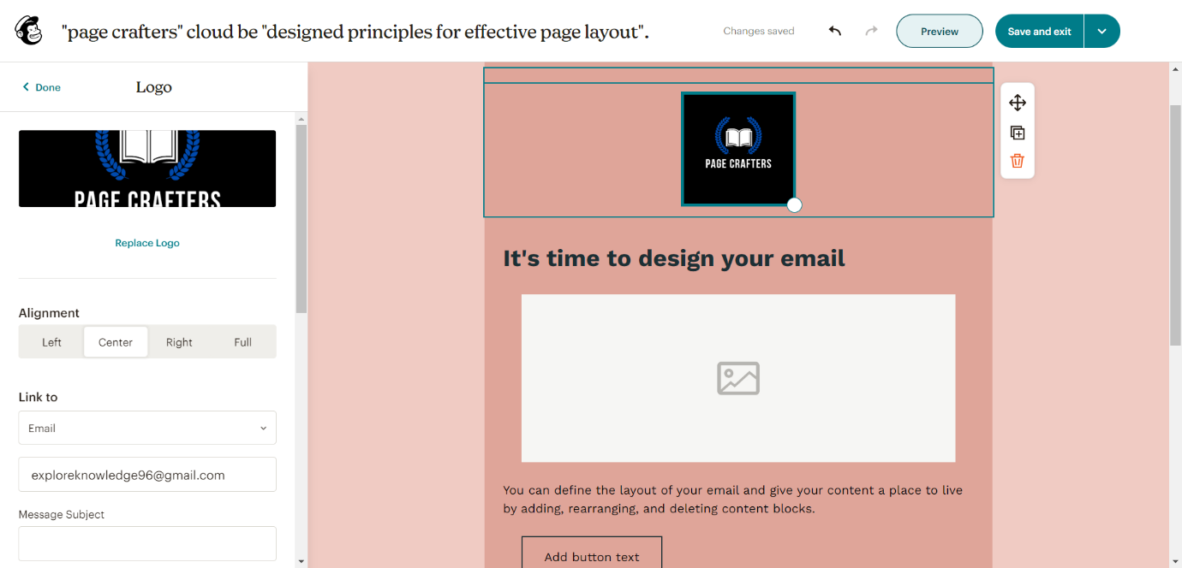



**STEP 4 TOUCH THE “SEND “**

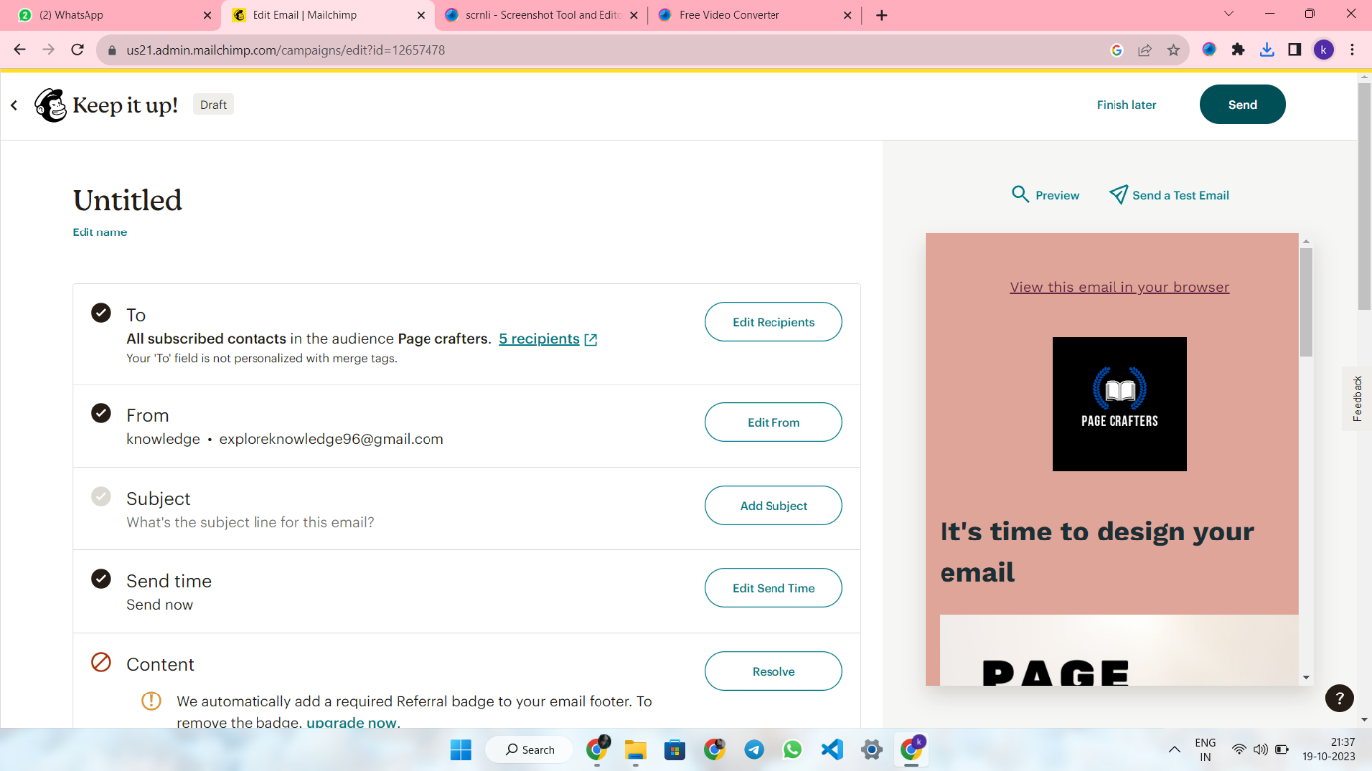

**STEP 6 TOUCH THE CHECK EMAIL REPORT AND RECEIVE THE MAIL!**

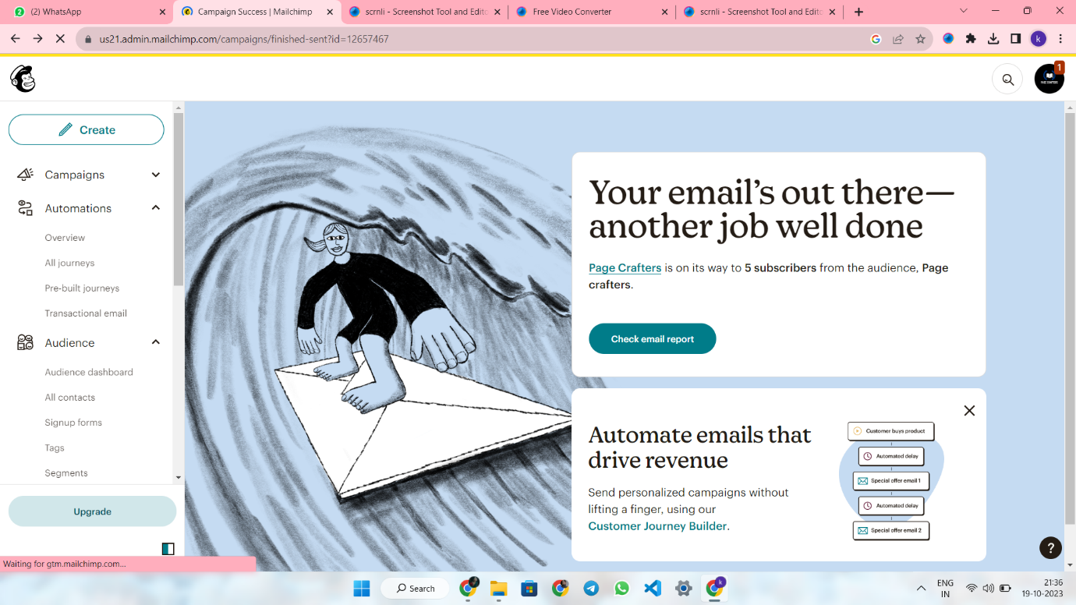

**STEP 7**

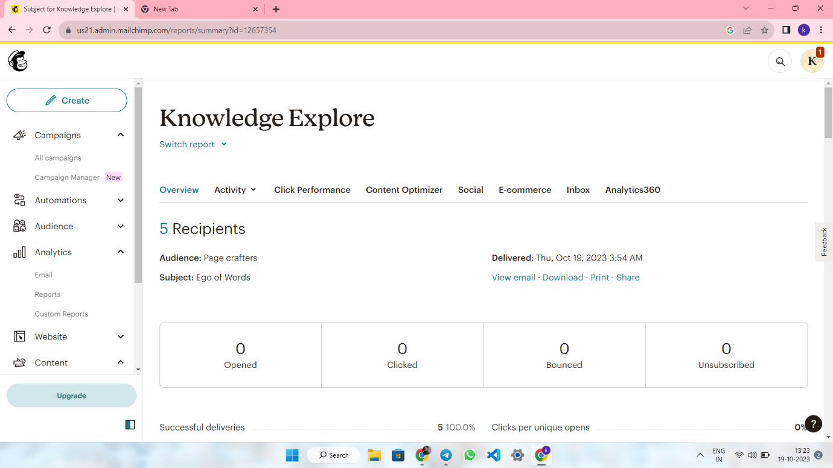

**INSERT THE PDF LINKS:**

**BRAND NAME : PAGE CRAFTERS**

**CATEGORY : BOOKS**

**E-MAIL :** [**exploreknowledge96@gmail.com**](mailto:exploreknowledge96@gmail.com)

**WEBSITE :** [**https://exploreknowledge96.wixsite.com/pagecrafters**](https://exploreknowledge96.wixsite.com/pagecrafters)

**MAILCHIMP :** <https://mailchi.mp/7a1f9390ba10/historical-legends-remarkable-figures-from-the-past>

**FACEBOOK :** [**https://www.facebook.com/people/Page-Crafters/61550192768049/**](https://www.facebook.com/people/Page-Crafters/61550192768049/)

**DEMO LINK :** [**https://drive.google.com/file/d/13Q0oSn10cPmQnLs37nNsmGK8LA4y9cNY/view?usp=share_link**](https://drive.google.com/file/d/13Q0oSn10cPmQnLs37nNsmGK8LA4y9cNY/view?usp=share_link)